AutoNova Installation Manual

Session: 2024 – 2028

Submitted by:
Ahmad Hassan Tanseel 2024-CS-811

Supervised by:
Mam Kalsoom Fatima

Subject :
Advanced DBMS

Computer Science Department University of Engineering and Technology, Lahore

(Faisalabad Campus)

Requirements to Run AutoNova Project

- Introduction

AutoNova is a Smart Car Showroom Management System developed using modern technologies including:

- C# Windows Forms
- PostgreSQL Database
- Python FastAPI
- Machine Learning (scikit-learn)
- Groq API

The project automates showroom operations such as customer management, inventory handling, booking management, AI-based recommendations, and machine learning price prediction.
To run the project successfully on another system, all required software, libraries, database configurations, and project files must be properly installed and configured.

- Required Software

The following software must be installed before running the project.

Software | Purpose
Visual Studio | Run C# Windows Forms frontend
.NET Framework | Support C# application
PostgreSQL | Database management
pgAdmin | Database handling
Python | Backend execution
FastAPI | Backend API framework

- System Requirements

Component | Requirement
RAM | Minimum 4 GB
Processor | Intel i3 or above
Storage | Minimum 2 GB Free Space

Operating System
- Windows 10
- Windows 11

- Required Python Libraries

The following Python libraries are required for backend and machine learning functionalities.
pip install fastapi
pip install uvicorn
pip install scikit-learn
pip install pandas
pip install numpy

- Project Files Included in ZIP

The ZIP file contains the following components:
- Frontend C# Project
- Backend FastAPI Files
- Machine Learning Model
- SQL Database Script

- Database Setup

Step 1: Install PostgreSQL
Install PostgreSQL and pgAdmin on the system.

Step 2: Create Database

Open pgAdmin and create a new database.

Example:
CREATE DATABASE csms1;

Step 3: Run SQL Script

Execute the provided database.sql file in pgAdmin to create all required tables.
Tables Included:
- Users
- Employees
- Cars
- Bookings
- Sales

- Backend Setup

Step 1: Open Backend Folder

Open the backend project folder in VS Code or terminal.

Step 2: Run Backend API

Execute the following command:
python api.py
This starts the FastAPI backend server.

- Frontend Setup

Step 1: Open Visual Studio

Open the C# Windows Forms project in Visual Studio.

Step 2: Configure Database Connection

Update PostgreSQL database connection string if required.
Example:
Host=localhost;
Port=5432;
Database=csms1;
Username=postgres;
Password=yourpassword

Step 3: Run Application
Click the Run button in Visual Studio to start the application.

- System Working Flow

The system follows the following workflow:

- User interacts with C# Frontend
- Frontend sends requests to FastAPI Backend
- FastAPI processes requests
- PostgreSQL database stores and retrieves records
- Machine Learning model predicts car prices
- Groq API generates AI recommendations
- Results are returned to the frontend

10. System Workflow Diagram

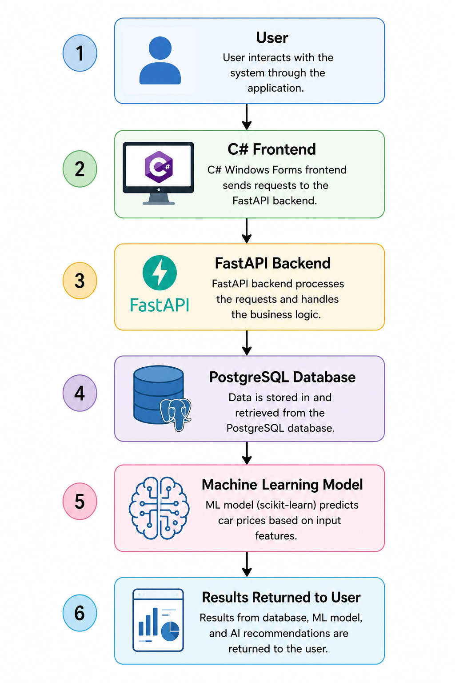

11. Features That Will Work

After proper setup, the following modules will function correctly:
- User Login & Signup
- Admin Dashboard
- Employee Dashboard
- Car Inventory Management
- Booking System
- Booking History
- AI Car Advisor
- Machine Learning Price Prediction

12. API Requirements

To use AI Car Advisor:
- Internet connection is required
- Valid Groq API key is required

13. Machine Learning Module

The Machine Learning module predicts estimated car prices based on the following inputs:
- Brand
- Model
- Year
- Mileage
- Engine Type
- Fuel Type
- Transmission
The frontend sends requests to FastAPI APIs which communicate with the trained scikit-learn machine learning model.

14. Steps to Run the Project

- Install PostgreSQL and pgAdmin
- Create csms database
- Run database.sql script
- Install required Python libraries
- Run backend using:
python api.py

- Open C# project in Visual Studio
- Run frontend application

15. Important Notes

- PostgreSQL service must be running
- FastAPI backend must start before frontend
- Correct database credentials must be configured
- Required Python libraries must be installed
- Internet connection is required for AI recommendations

16. Troubleshooting

Problem | Solution
Database connection error | Check PostgreSQL credentials
API not working | Ensure backend server is running
ML prediction error | Verify Python libraries installation
Login issue | Check database connectivity

18. Conclusion

By installing the required software and configuring the provided files correctly, the AutoNova Car Showroom Management System can run successfully on another computer.
The project combines:
- Database Management
- Desktop Application Development
- Artificial Intelligence
- Machine Learning
to provide a modern and smart showroom management solution.

